-------------~.--------- --
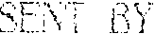
1 10-\11
3:18PM:SWRI FIRE TECHNOLOGY~
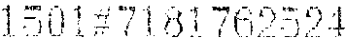
07:= 1/
S O U T H W E S T
R E S E A R CH I N S T I T U T E
CHEMISTRY AND CHEMICAL ENGINEEERING DIVISION DEPARTMENT OF FIRE TECHMOLOGY
FAX: (512)522-3377
TEST FOR EVALUATING THE SMOKE GENERATION CHARACTERISTICS OF SOLID- HATERIALS (ASTM E662-83/NFPA 258)
TEST REPORT
MATERIAL 101 HONEYCOMB CARDBOARD WITH PLAME SAFE PAPER SAFE 7030 APPLIED AT A SPRBAD
RATE OF 14 LR PER 1000 SO. FT. (WET WEIGHT) ON EACH LINER BOARD, AND .f1,.T A SPREAD RATE OF 8 LB PER 1000 SQ. FT. (YET WEIGHT)
ON THE MEDIUH
SwRI PROJECT NO.: 01-4510-094 TEST DATE: NOVEMBER 26, 1991
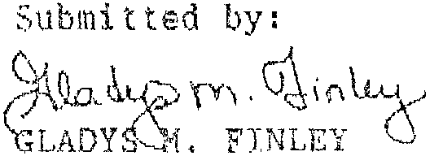
Prepared for:
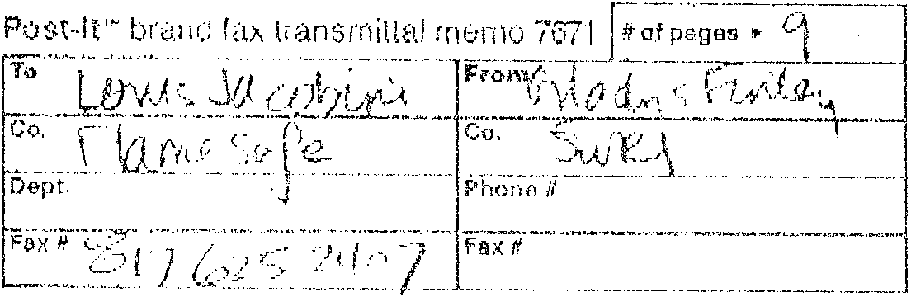
WEYERHAUSER
p, O. BOX 8690 JACKSON HS 39284
NOVEMBER 1991
Approved by:

Alex B. Wenzel Director
Department of Fire Technology
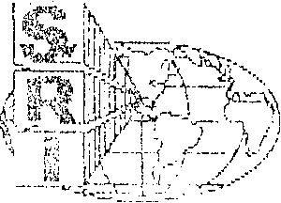
SAN ANTONIO TEXAS
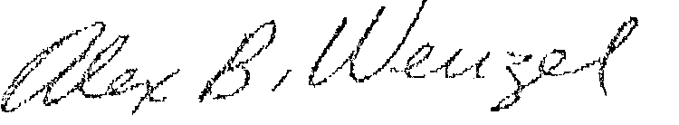

SENT BY;
12-10-81
3 : 43PJ1 ; Sv,R j f! RE TECH\OLOGY ~
1501#718176252407:# 9/ 8
INTRODUCTION
This report presents the results of a smoke test in accordance with ASTM £662 "Standard Test Method for Specific Optical Density of Smoke Generated by Solid Materials. The values for the smoke generation of the material in this report were obtained in strict accordance with the standard procedure. They shall be used solely be used to define the properties of the described materials when exposed to heat and flames under controlled laboratory conditions. The results shaI1 not be used as measures of smoke hazard under actual fire conditions or for toxicological assessment. The samples were prepared by the Client and received ready for testing.
This test method is used to determine the smoke generated by solid materials using a Smoke Density Chamber. Specimens measuring 73 x 73"lnm are tested in the vertical mode, while exposed to a radiant beat flux of 7.5 watts per square centimeter. Triplicate runs are conducted in each the flarn¹11g and nonflaming exposure modes. Results are expressed in terms of Specific Optical Density (Os), which is defined as the measure of the amount of smoke produced per unit area by a material due to non flaming pyrolytic decomposition and flaming combustion.
The results apply speeifical1y to the specimens tested, in the manner tested, and not to the entire production of these or, similar materials; nor to the performance when used in combination with other materials. All test data are on file and are available for review by authorized persons.

SENT BY;
12-10-81
3: ·50PM : SwRI F I RE TECHNOLOGY....,
1501#71 76252407:#
SUMMARY OF RESULTS EXPOSURE: FLAMING
WEYERHAUESER
SwRI Project No: 01-4510-094
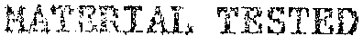
'type:
Identification:
Construction:
Fire-retardant treated cardboard None
Honeycomb cardboard with Flame Safe Paper Safe 7030 applied at a1 spread rate of 1. lb per 1000 sq. f t . (wet weight) on each liner board, and at a spread rate of 8 lb per 1000 sq. ft. (wet weight) on the medium.
Brown
Color:
Total Thickness (nominal):
0.38 in. (9.53 mm)
Specimen Orientation:
Radiant Heat Flux:
VERTICAL 2.5 W/CM 2
SPECIFIC OPTICAL DENSITY (Ds) DUHING 20 HINUTES
RUN | # | 1.5 | min | 4 | min | HAX | Ds | Time | to | J1A.X | Os | HAX | Ds | (corrected)
 |  |  |  |  |  |  |  | (min:sec)
-~----- |  | .•...... _------ |  | ~ ... .--_ .•.•....•..• -- |  | _._-_._-.- |  | ------ --- ---- _ .. - ---._-- |  |  |  | --_._----------------
1 |  | 16.7 |  | 33.3 |  | 39.3 |  |  | 7:30 |  |  |  | 37. 4
2 |  | 21.9 |  | 37. '7 |  | 44.2 |  |  | 7:55 |  |  |  | 43.6
3 |  | 19.0 |  | 33.5 |  | 39.1 |  |  | 7:35 |  |  |  | 38.5
 |  |  |  |  |  | -_ .. _-~--~- |  |  |  |  |  | ,
AVERAGE |  | 19.2 |  | 34.8 |  | 40.8 |  |  |  |  |  |  | 39.8
COMMENTS
Run 1 immediately emitted whi te smoke and charring, but no ignition was observed. Run 2 showed ignition at the source at 8 seconds and was out at 10 seconds. In Run 3, ignition occurred at 5 seconds and was out at 20. Reignition occurred at 45 and went out at 50 seconds.
2

SENT BY:
12-10-91 3:50P~ :S~RI FIRE TECHNOLOGY~ l501#718176252407:# it 8
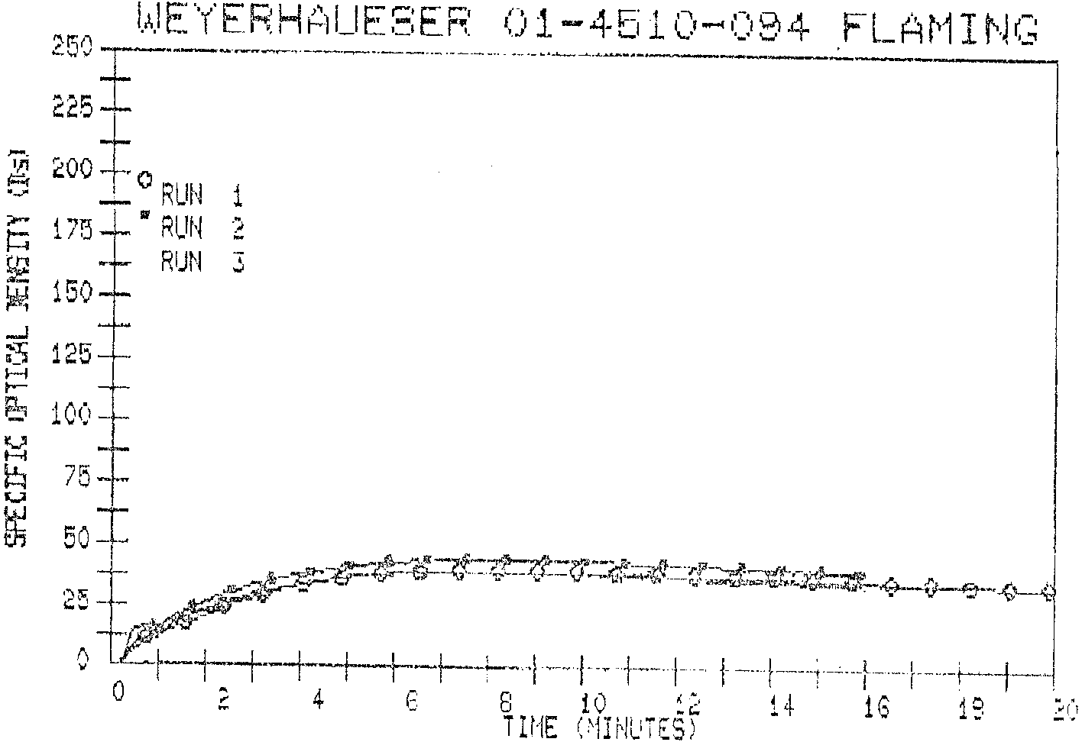
3

SENT BY:
1 10--81
3 :51PM : SwRI FIRE TECH\OLOGY~
lSUl~718176252407:# 5/ 8
SUMMARY OF RESULTS EXPOSURE: NONFLAMING
WEYERHAEUSER
SwRI Project No: 01-4510-094
MATE:RIAI. TESTED
Color:
Total Thickness (nominal):
Fire-retardant treated cardboard None
Honeycomb cardboard with Flame Safe Paper Safe 7030 applied at a spread rate of 1 lb per 1000 sq . ft . (wet weight) on each liner board, and at a spread rate of 8 Lb per 1000 sq . f t , (wet weight) on the medium
Br own
Type:
Identification:
Cons truction:
0.38 in. (9.53 mm )
Specimen Orientation:
Radiant Heat Flux:
VERTICAL
2.5 W/CW2
SPECIFIC OPTICAL DENSITY (Os) DURING 20 MINUTES
RUN | # | 1.5 | min | 4 | min | MAX | Ds | Time | to | MAX | Ds | MAX | Ds | (corrected)
 |  |  |  |  |  |  |  | (min:sec)
-_--.".,....,...... .•. ~ |  | ------- |  | '-"-''''------- |  | -------- |  | ._ . ___ ._ .. _______ '_ ........... L_ |  |  |  | ---~-~--.--~-~---,----
1 |  | 15.1 |  | 32.2 |  | 38.0 |  |  | 7:25 |  |  |  | 36.9
2 |  | 24.1 |  | 47.0 |  | 51{.6 |  |  | 8: | 0 |  |  | 53.5
3 |  | 15.9 |  | 36.4 |  | 39.8 |  |  | 6:55 |  |  |  | 39.2
------'-- |  | ----- ......... ,,,- |  | _.---- .. _--- |  | ._-_ ...... _ •...... - |  |  |  |  |  | ._--------- - -- ----- --- ---_ .•.•.. , ...
AVERA.GE |  | 18.3 |  | 38.6 |  | 44.1 |  |  |  |  |  |  | 43.2
COMMENTS
White smoke and char occurred at 20 seconds in Run 1 and at 19 seconds in Runs 2 and 3.
4

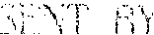
12-10-91 :3:52PM : S\\R I FIRE TECHNOLOGY-~ 1301';
WEYERHAUESER 01-4510-084 NONFLAMING
:::1----- --- ----------1
'm ~oo~-
e U RUrj 1
5 175 •• RUN 2
r.g I RUN 3 l1J 150-
...J
"8 125
H
,.... -
e:, 100
'-' H
~ 75
'-' -M~-_....._ _ __<l •••.••••••.••.•• ____..... _
~_A-W -...
en :SO -I- ~"'~~~':\i--~~~'~J=.4-', "~,<;\rn+__o_~_e_-~-~-e--,'
,r ~-pr
25 +1 ~., .e ,~-,
• >ef" ." "., , f +-,+ .. +--+.-t-
- L<Jt- "l--J-t-+--;-. r-'" I ; +- t~ f- - \~- - 14 '1 t3 18 20
o 2 4. G rUlE (~lnjUTE:,)
5
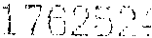
07: !-,
~
