THE DEPARTMEN T OF
FIRE TECHNOLOGY


FIRE ENDlJRANCE AND HYDROSTATIC EVAL1UATIONS BASED ON IMO RES0LUTION A.753(18); APPENDIX 2; AND ASTM F1173-95 SECTION A5 WET CONDITION Cl.ASSIFICATION OF WAT'ER-FILLED PLASTIC PIPE
FINAL REPORT'
SwRI Project No. Ol-1205-406 August 1998

Prepared for:
Conley Corporation 2195 East 91st Street Tulsa, Oklahoma 14137
SOUTHWEST RESEARCH INSTITUTE
Chemistry & Chemical Engineering Division
SAN ANTONIO, TEXAS
Houston, Texas· Detroit, Michigan · Washington, D.C.

S O U T H W E S T R E S E A R C H I N S T I T U T E
CHEMISTRY AND CHEMICAL ENGINEERING DIVISION DEPARTMENT OF FIRE TECHNOLOGY FAX (210) 522-33n

6220 CULEBRA ROAD • POST OFFICE DRAWER 28510 • SAN ANTONIO, TEXAS. USA 78228·0510 • (210) 684·5111 • TELEX 244846
FIRE ENDURANCE AND HYDROSTATIC EVALUATIONS BASED ON IMO RESOLUTION A.753(18); APPENDIX 2 AND ASTM F1173-95 SECTION AS WET CONDITION CLASSIFICATION OF WATER-FILLED PLASTIC PIPE

FINAL REPORT
SwRI Project No. 01-1205-406 August 1998
Prepared for:
Conley Corporation 2795 East 9181 Street Tulsa-Oklahoma 74137
Submitted by:
~
Charles C. Bailey
Sr. Engineering Technologist Fire Testing Services
Approved by:
por
Alex B. 'Wenzel Director
Department of Fire Technology



This report is for Ihe information of Ihe cIent. It may be used In lis entirety for the purpose of MCUIIng product accepIance ftom duly c:onstituted ~ authOrities. This report shall not be I'lIProduc8d except In full, WIthout the wrilIlln 8ppl'(MII of SwRl. Nailher tIlis
report nor 1he name of the Institute 8lIlIII be used In publicity or .a-tiIlng.

1.0 OBJECTIVE
2.0 CLASSIFICATION CRITERIA

The wet condition fire endurance and hydrostatic evaluation described herein, were conducted by Southwest Research Institute's (SwRI1s) Department of Fire Technology located in San Antonio, Texas, for Conley Corporation located in Tulsa, Oklahoma. The test was performed on a 6-in. diameter plastic pipe assembly with a connector sleeve joint coated with Flame Safe Chemical Corporation's "Fire Poly FPCC." The specimen, identified as Conley epoxy schedule 20, 6-in. FLGX FLG Spool pipe, was received by SwRI on June 9,1998. The evaluation was conducted using the specifications and protocol described in International Maritime Organization Resolution (!MO) Resolution A. 753(18) and American Society for Testing and Materials (ASTM) Fl173-95 for Level 3 Wet Condition Classification for Plastic Pipe. The test procedure involves subjecting a water-filled plastic pipe to two separate endurance tests while under pressure. Note that the results apply only to the specimens tested, in the manner tested, and not to the entire production of this or similar materials, nor to the performance of this material when used in combination with other materials.
The first test is a fire exposure from a specific air mixed propane gas fired burner array producing an open flame which is adjusted to envelope the base of each water-filled pipe specimen for a period of 30 min while pressurized to approximately 43 psi (3 bars). The second test is a static hydrostatic pressurization test that subjects the water-filled fire tested assembly to the pipe's rated working pressure, (150 psig 10.34 bars for these specimens). The pressure is to be maintained for 15 min without exceeding a water leakage rate of 0.05 gal/min (0.21/min).
Piping systems must meet the following criteria to qualify for Level 3, wet condition piping:
During the 3D-min fire endurance exposure and while maintaining a static pressure of 43.5 psig (3 ± 0.5 bars), no leakage from the specimen should occur. Slight weeping through the pipe wall may be accepted.
After the fire test, the water-filled specimen is allowed to cool to ambient temperature and pressurized to the rated pressure of the pipe and held at that pressure for 15 min. Leakage rate should not be in excess of 0.05 gal/min (0.2 l/min).
•
•
Conley Corporation
SwRI Project No. 01-1205-406

3.0 TEST CONFIGURATION
4.0 FIRE ENDURANCE TEST MATRIX
The fire endurance tests were run on June 11, 1998. The ignition source used in this program was an air mixed propane gas fired burner array as specified above. The burner and specimen holder were mounted on cement blocks laid flat on the floor of the test room to achieve a height to the top of the burners of 14 in. (35.5 cm). This placed the bottom of the specimen at a height of approximately 1.58 ft (48 cm) above the floor (see photograph No. A-I). The specimen was placed into the steel support holders centered parallel over the burner array axis such that the flame impinged on the base of the specimen. After filling with water, all possible air was expelled from the specimen. The test was initiated by pressurizing the specimen and then igniting each burner. Complete ignition of the burner array marked time zero.

The test was performed at the Department of Fire Technology's air conditioned high bay testing facility. The fire endurance burner consisted of a multiple burner array with two rows of five Sieven No. 2942 burners as shown in Figure 1. The burner system was calibrated, and all testing conducted, using technical grade propane (98 percent purity) to obtain an average heat flux of 36,011 BTU/hr sq ft (113.6 kW/m sq) measured 5 ± 3/8 in. (12.5 ± 1 cm) above the centerline of the burner array. The heat flux corresponds to a total heat release rate of 221,780 BTU/hr (65 kW). The pressurization of the specimen was maintained manually and was monitored with both a calibrated pressure gauge and a voltage transducer connected to the computer data acquisition system. A pressure relief valve set at 48 psi (3.3 bars) was mounted in the opposite end cap.
5.0 HYDROSTATIC TEST MATRIX
The hydrostatic test was run on June 12, 1998. The test was conducted using an air activated low volume high pressure pump system to provide the required rated water pressure. The specified pressure of 150 psi was continuously monitored and adjusted by visual readings of a calibrated pressure gage (Wika brand 0-200 psi; 2-in. diameter dial) and an electronic pressure transducer with digital readout.
Conley Corporation
2 of 4
SwRI Project No. 01- J 205-406

190
1⁷⁰
I
170
QO
so
90
i
;r;
~
.2Q
kL ~
32
100
(b) •• _ ot one lUMr
Fire endurance test: burner asemblv (all dimensions in mm)
100
c ••• -
15002:100
800t60
(\
I
r\
I
\ 12h10 J IMl U.lJ.U~...L
Fire endurance test: stand with mounted sample (all dimensions in mm)
Resolution A753(18)- 355
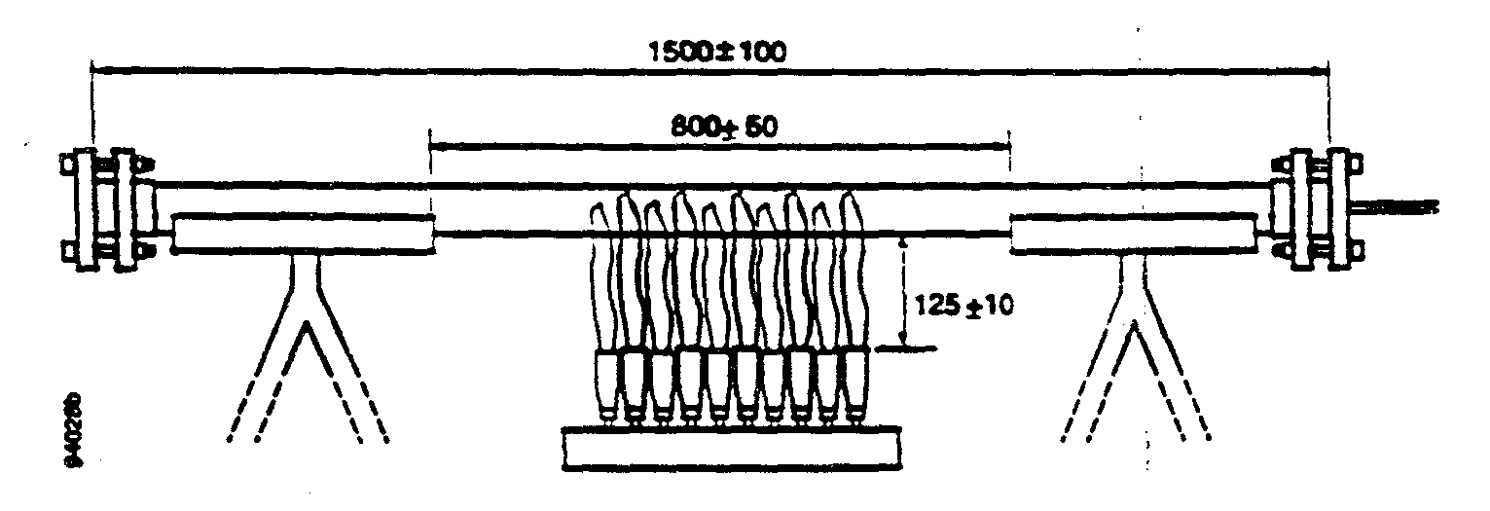
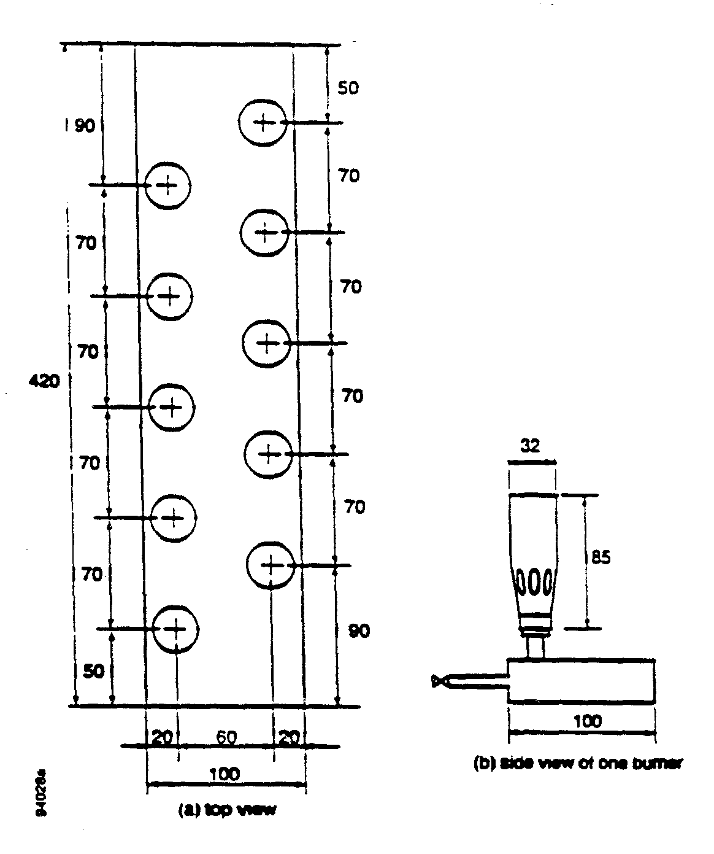

Figure 1. Multiple Burner Array with Two Rows of Five Sievert No. 2942 Burners.
Conley Corporation
3 of 4
SwRI Project No, 01-1205-406

6.0 TEST RESULTS
Photographic documentation is presented in Appendix A. Appendix B consists of Flame Safe letter dated June 16, 1998, stating coating specifications.

The specimen, identified as Conley epoxy schedule 20, 6-in. FLGX FLG Spool pipe passed both the fire endurance classification criteria and the hydrostatic test pressure classification in accordance with the specifications and protocol described in IMO Resolution A. 753(18) and ASTM Fl173-95 for Level 3 Wet Condition Classification for Plastic Pipe.
A videotape of the fire endurance test is included as part of this report.
Conley Corporation
4 of 4
SwRI Project No. 01·1205·406

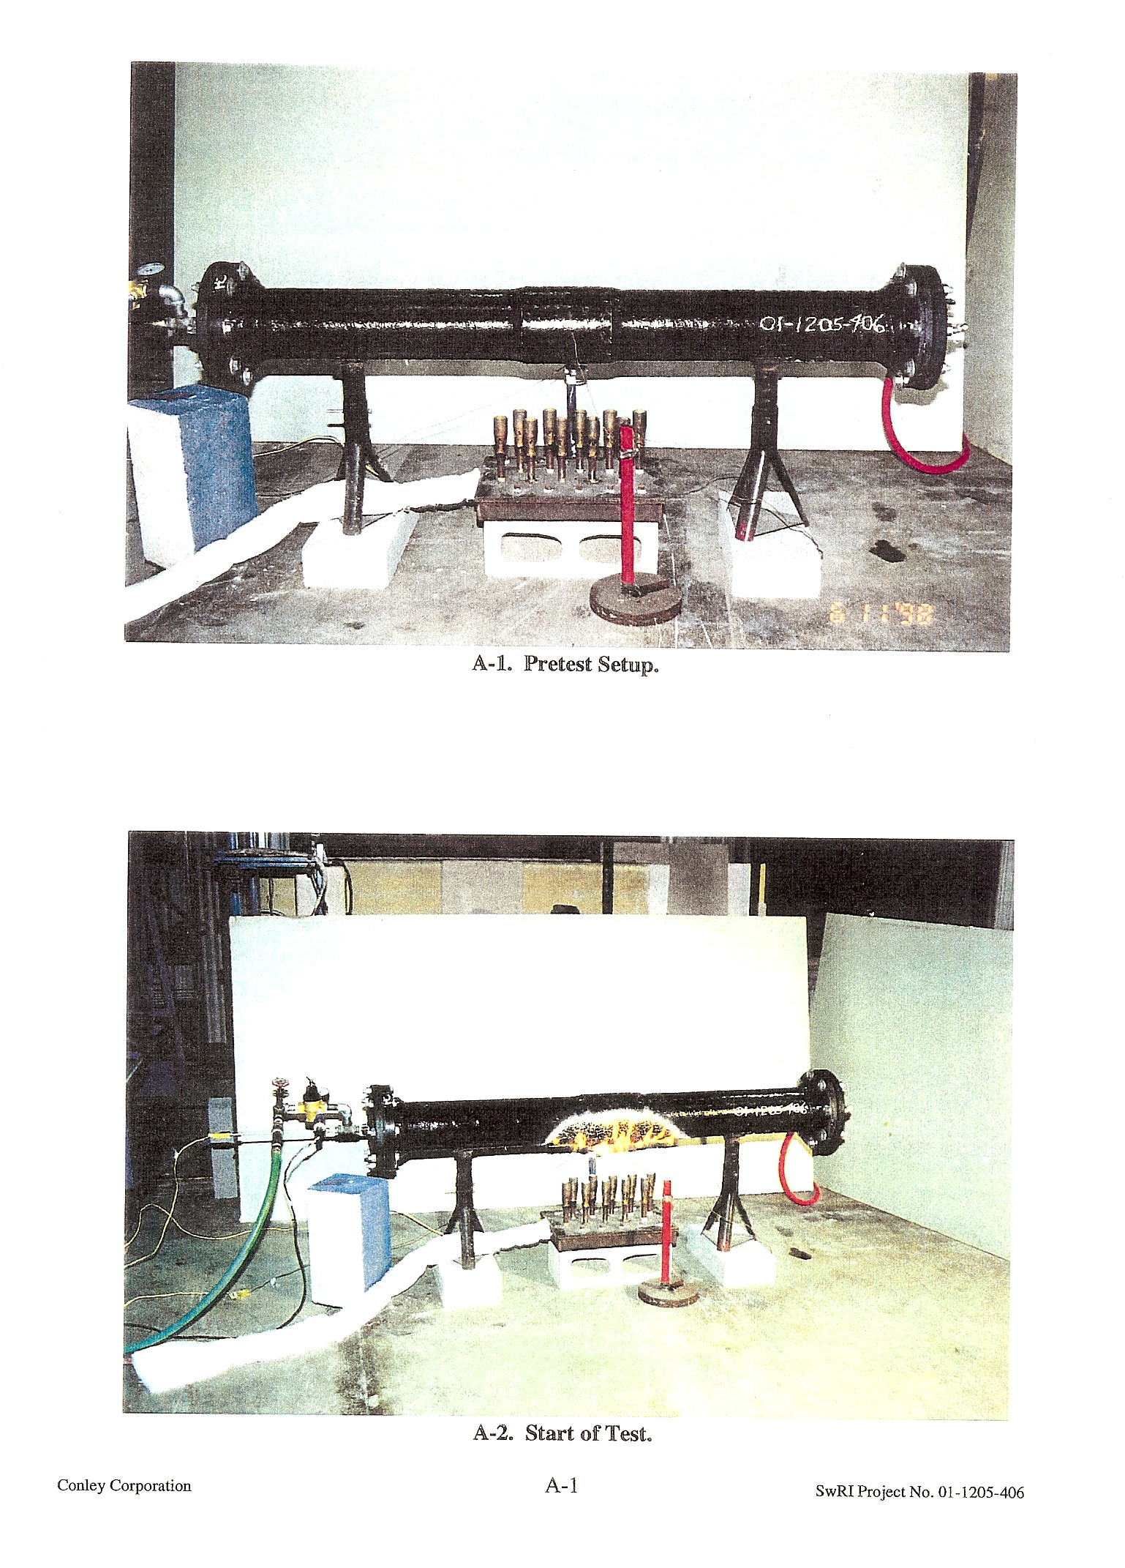

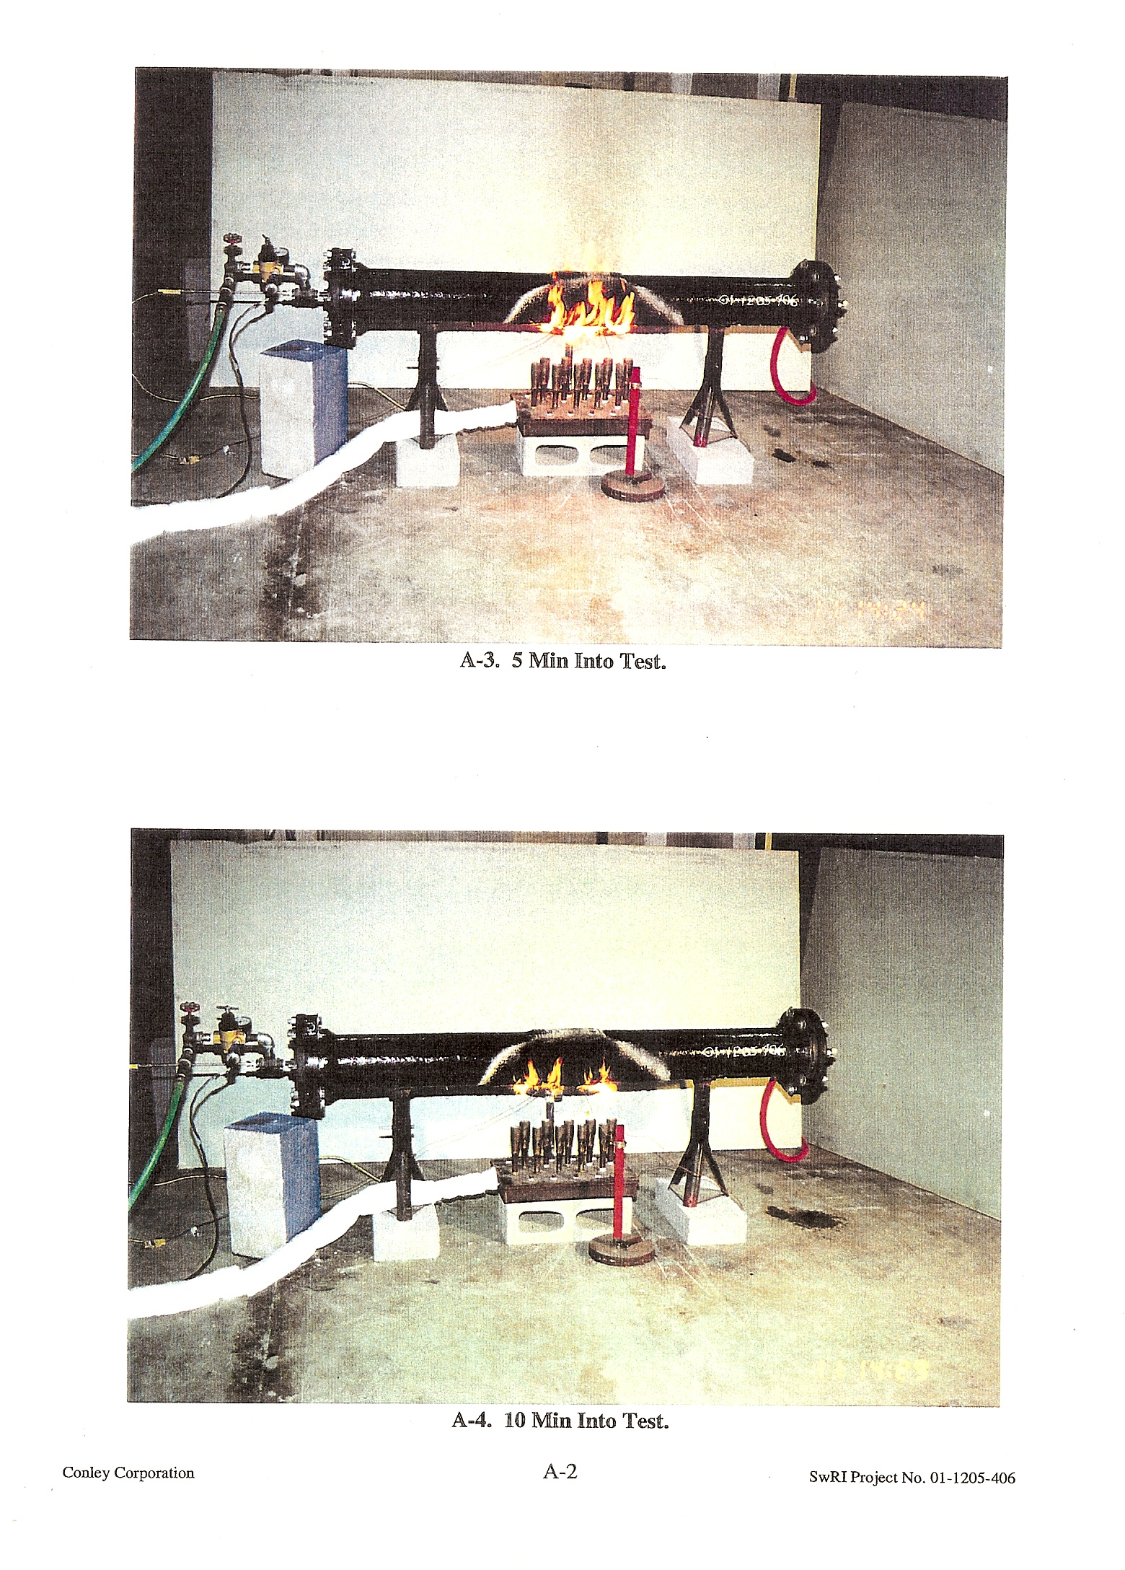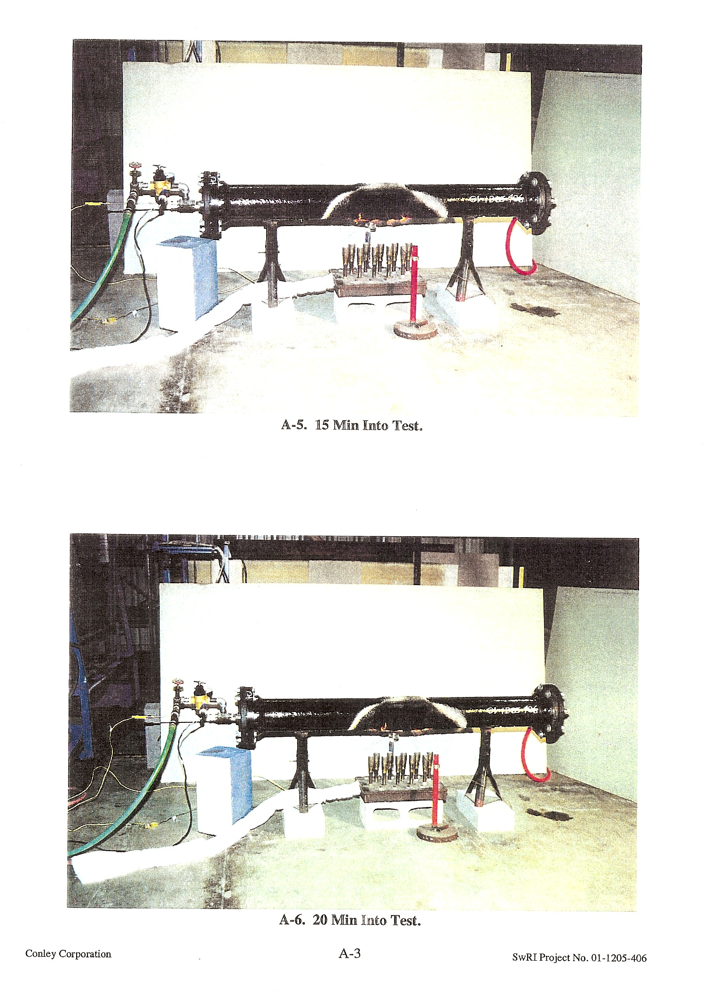

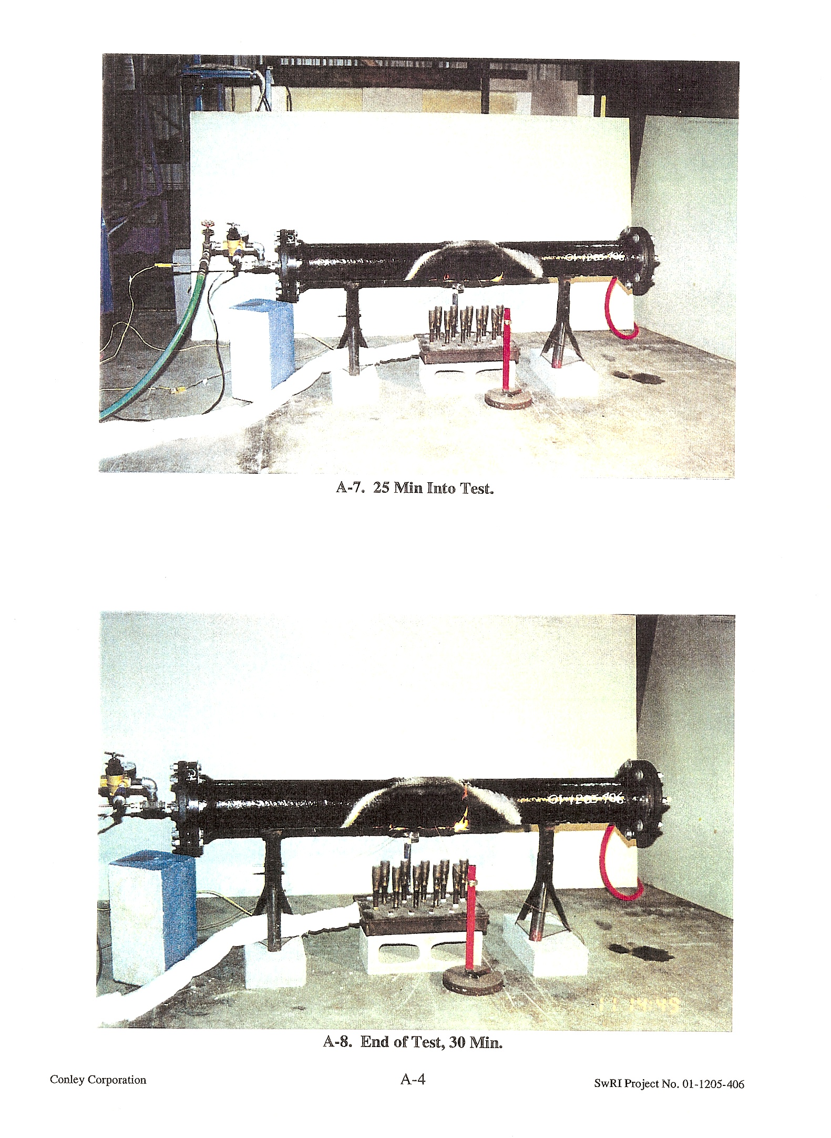
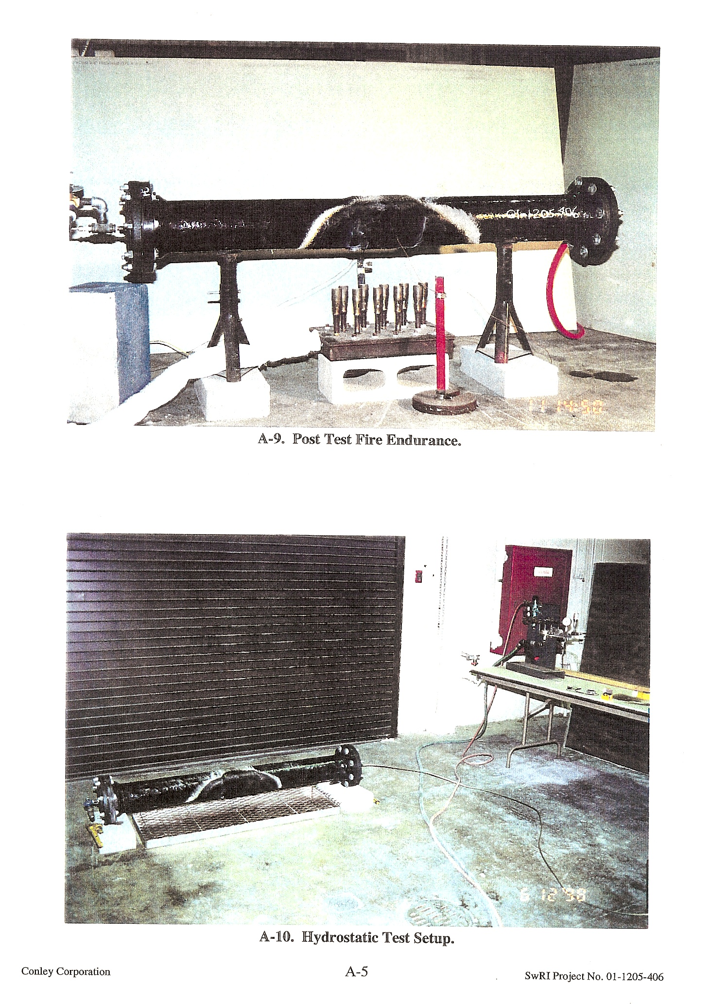

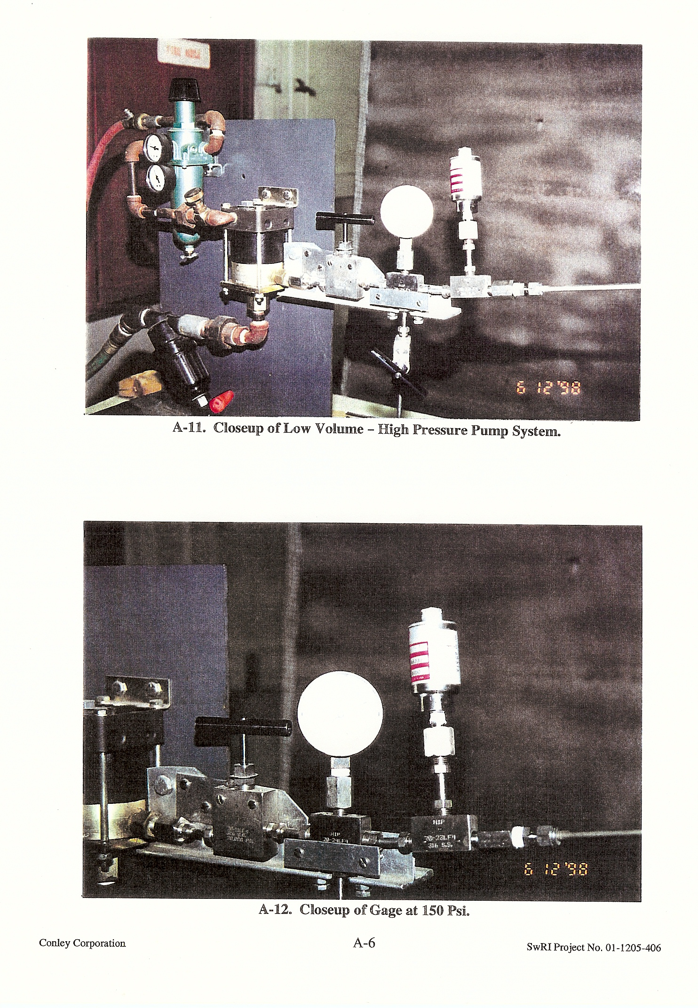
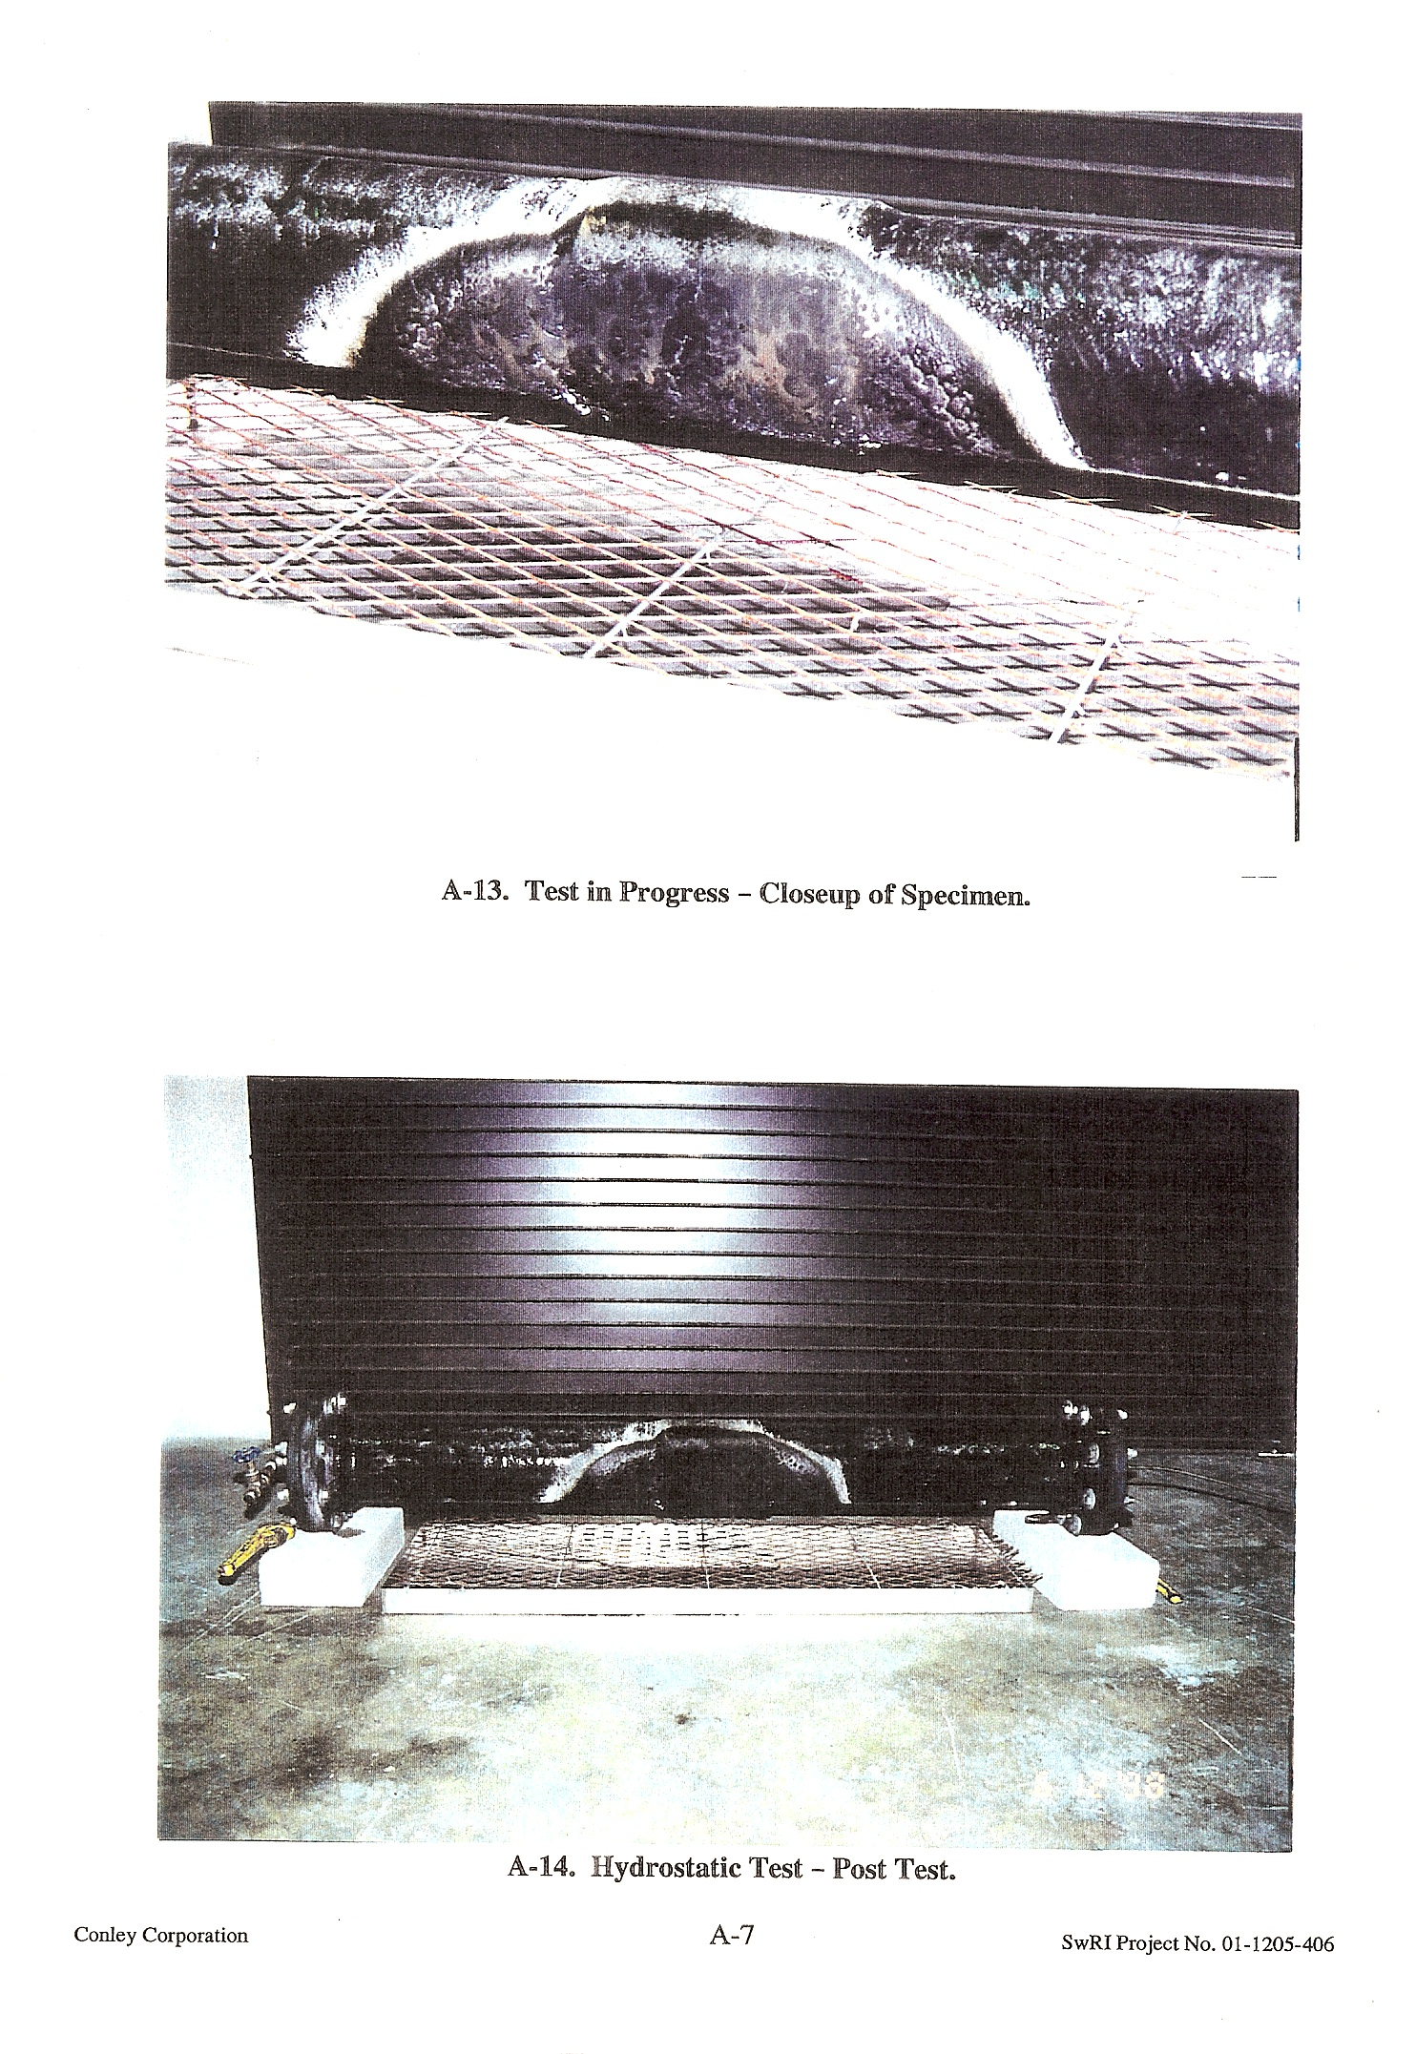

Conley Corporation
SwRi Project No. 01-1205-406
APPENDIX B
COATING SPECIFICATIONS (Consisting of 1 Page)

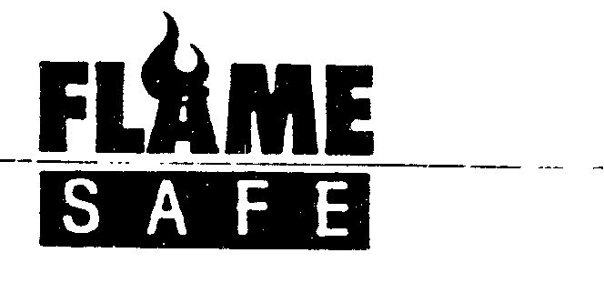
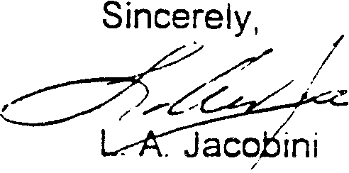

June 16. 1998
Chip Bailey
Southwest Research Institute 6220 Culebra Road
San Antonio, Texas 78284
RE: Tests conducted for Conley Corporation on June 11 th and June 12th, 1998
Dear Chip:

The following is the specifications for applying fire retardant coating to the composite pipe and coupling furnished by Conley Corporation to Southwest Research Institute for testing.
SAMPLE PREPARATION prepared by Conley Corporation
Pipe

Flame Safe Chemical Corporation's Fire Poly FPCC was applied to test specimen in three coats at a final coverage rate of 350 square feet per gallon. Each coat was allowed to dry to the touch before application of the next. The final coat was allowed to dry. The amount of coating applied was determined by weight difference. The pipe was then cut in half.
Coupling

Flame Safe Chemical Corporation's Fire Poly FPCC was applied to test specimen in three coats at a final coverage rate of 350 square feet per gallon. Each coat was allowed to dry to the touch before application of the next. The final coat was allowed to dry. The amount of coating applied was determined by weight difference.
Connection

Two sections of pipe were connected by the coupling using Conley Corporation's standard adhesive. Flame Safe Chemical Corporation's Fire Poly FPCC binary coating (field kit) was prepared according to the manufacturer's specifications. A single coat of the Flame Safe binary coating was applied by brush at the rate of 200- 250 square feet per gallon extending a minimum of four (4) inches beyond each end of the coupling/pipe joint with beading allowed to occur at the raised edge of the coupling to the surface of the pipe. The amount of coating applied was determined by weight difference. The completed test specimen ~as allowed to d~ to the touch before delivery to SouthwestResearch Institute,
San Antonio, Texas for testing. . 'i_uE\\--

FIRE PREVENTION TECHNOLOGIES d/b/a FLAME SAFE CHEMICAL CORPORATION
2653 Warfield Ave .. Ft. Worth. TX 76106 Ph: (817) 740-9197 Fax: (187) 740-9199
Conley Corporation B-1 SwRI Project No. 01.1205.406

